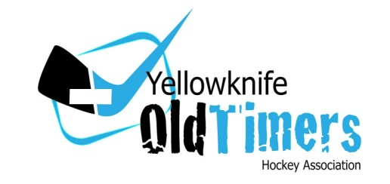

Meeting Minutes
Novermber 2nd, 2015 – 6pm

- Call to order
- 6:06pm

- Approval of last meeting minutes
- Motion: Dave (JTFN), 2nd Artie (Northbest)

- Reports:
President – No issues to report
Vice President – No issues to report
Treasurer
    - Need to be aware that it takes 5 business days to cancel ice with the City
    - Its $250+ for every ice time
    - Our bylaw only requires 48 hours notice to cancel a game, but we are still leaving ice times unused and paying for them in full
Discipline Chair – No issues to report
Referee in Chief
    - Ref Clinic will be held Nov. 11 @ YK1 Building
    - Will look to provide a schedule to the league and contact information for the officials
Scheduler – No issues to report

- Great Slave Classic Sign-up
- 35 players signed up so far
- Cut-off will be Thursday the 5th
- GSC Schedule
- Draft will be Monday the 9th
- Games played 12th – 14th
- League Fees
- All teams have met the first installment
- YKCA Update
- City has indicated we are on schedule
- Adult Skills Clinic
- WIMPS will be hosting an “Adult” practice session(s)
- Looking for volunteers (coaches) to run the sessions
- One session in each of Nov/Dec/Jan
- Game Cancellation Fines
- Two teams did not give 48 hours’ notice and don’t think they should pay
- May have to consider having Shinny when we can’t fill games slots, but do not have 5 days to cancel
- League needs to clarify who the notification is sent to and how
- Motion: 72 hours notice is required to cancel an ice time, the notification must be sent to Mike (President), Stephane (Scheduler), & Terry (RiC).
- Motion by Artie (Northbest), 2nd by Frank (J&A)
- Carried
- New Business
- Players must be 35 to lace em up, not almost 35!
- Subway & TAIT likely to cancel Dec. 19 – 10:30 game
- Adjournment
- 6:38pm

